EXPT NO: 7 | GENERATE SYNTHETIC IMAGES USING A GENERATIVE ADVERSARIAL NETWORK (GAN)
DATE: 05/10/2026

PRE-LAB QUESTIONS (PROVIDE BRIEF ANSWERS TO THE FOLLOWING QUESTIONS)
PRE-LAB QUESTIONS – BRIEF ANSWERS:
1. What is a Generative Adversarial Network (GAN)?
A GAN is a deep learning model used to generate new data, such as images, that look similar to real data.
2. What are the roles of the Generator and Discriminator in a GAN?
- Generator: Creates fake/synthetic images from random noise.
- Discriminator: Identifies whether an image is real or generated.
3. Why are GANs used for synthetic image generation?
GANs can learn the patterns of real images and generate new images that look realistic.
4. What is the difference between real images and synthetic images?
- Real images: Images collected from an actual dataset.
- Synthetic images: New images created by the Generator.
5. Explain the concept of adversarial training in GANs.
Adversarial training means the Generator and Discriminator compete with each other. The Generator tries to create realistic images, while the Discriminator tries to detect fake images. Through this process, the Generator improves its image quality.

AIM
To implement a Generative Adversarial Network (GAN) for generating synthetic images by training a Generator and Discriminator on an image dataset and evaluating the quality of the generated images.

SOFTWARE REQUIREMENTS
- Python
- TensorFlow / Keras
- Google Colab
- GitHub
- NumPy
- Matplotlib
- Pandas

OBJECTIVES
Students will be able to:
- Understand the architecture and working of Generative Adversarial Networks.
- Understand the roles of the Generator and Discriminator.
- Prepare and preprocess an image dataset for GAN training.
- Build a Generator network for synthetic image generation.
- Build a Discriminator network for distinguishing real and generated images.
- Train a GAN using adversarial learning.
- Generate synthetic images using the trained Generator.
- Visualize and analyze the quality of generated images.

PROCEDURE
PART A: DATASET PREPARATION AND IMAGE PREPROCESSING
Perform the following tasks:
- Load an image dataset such as the MNIST handwritten digit dataset.
- Explore the dataset and examine sample images.
- Check the number of images and image dimensions.
- Display sample images from the dataset.
- Normalize the pixel values to the range [-1, 1].
- Reshape the images into the required input format.
- Prepare the dataset for batch-wise training.
- Create a data pipeline using appropriate TensorFlow/Keras utilities.

CODE:

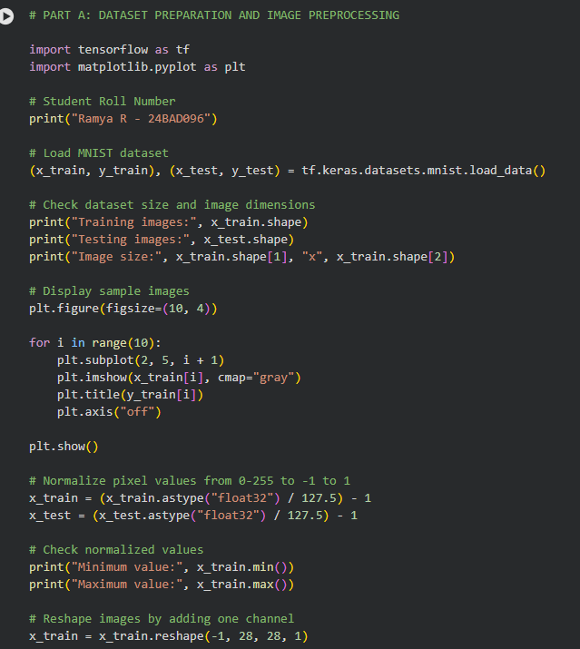
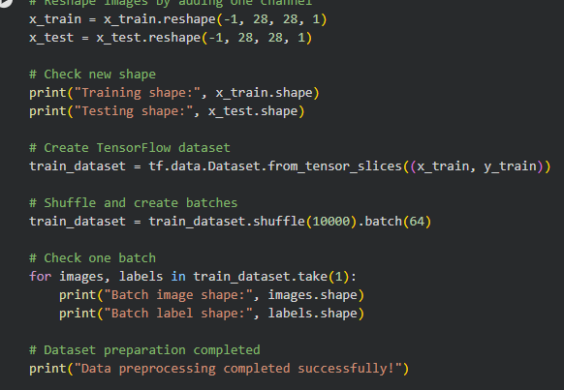

OUTPUT:
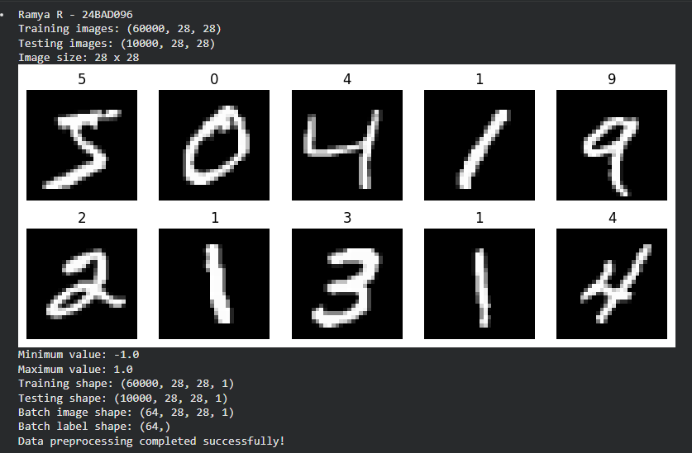

PART B: IMPLEMENTING THE GENERATOR
Perform the following tasks:
- Define a random noise vector as the input to the Generator.
- Create the Generator using appropriate neural network layers.
- Use Dense and convolutional/transposed convolutional layers to generate images.
- Apply appropriate activation functions.
- Generate an image from a random noise vector.
- Display the generated image before GAN training.
- Display the Generator model architecture and summary.

CODE:
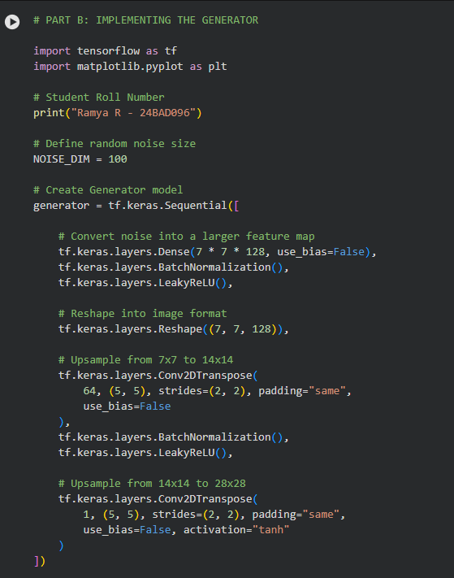
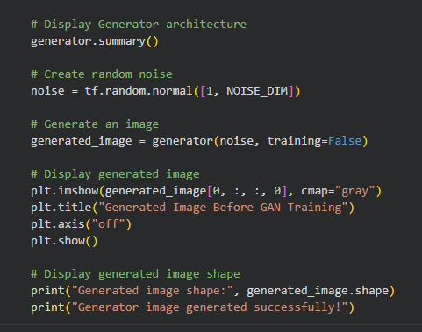

OUTPUT:
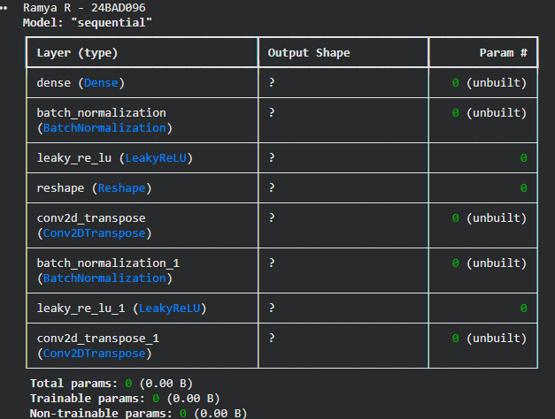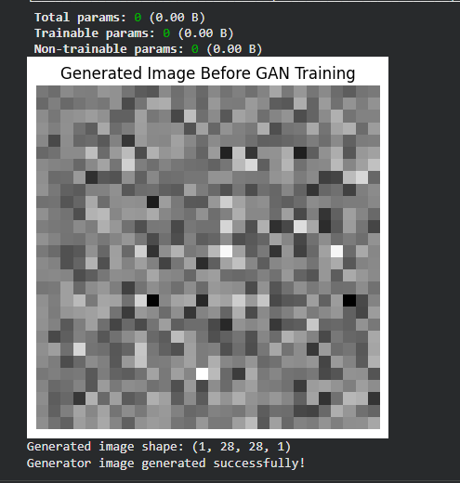

PART C: IMPLEMENTING THE DISCRIMINATOR AND GAN MODEL
Perform the following tasks:
- Create a Discriminator network to classify images as real or generated.
- Add convolutional layers to extract image features.
- Add appropriate activation functions.
- Add a final output layer for binary classification.
- Compile the Discriminator using:
  - Appropriate optimizer
  - Binary cross-entropy loss
- Combine the Generator and Discriminator to form the GAN.
- Display the Generator and Discriminator model summaries.
CODE:
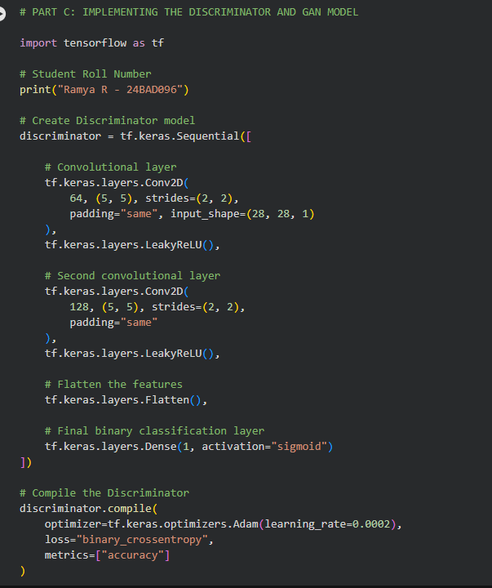
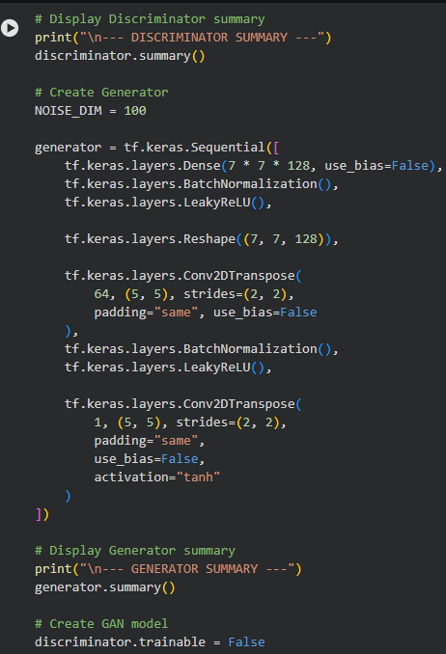
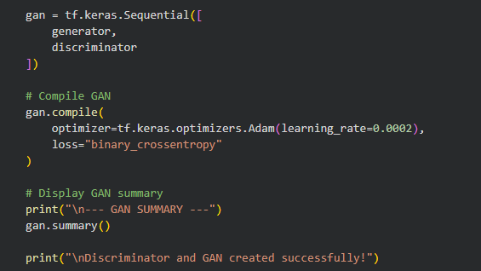

OUTPUT:
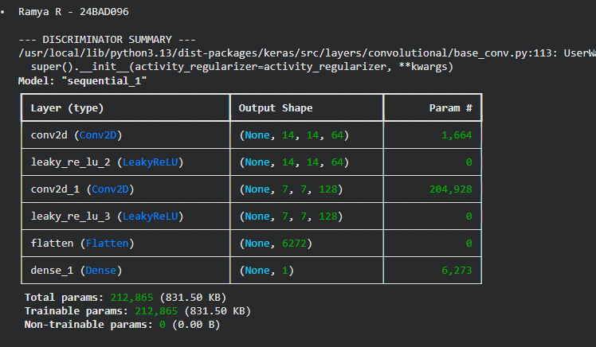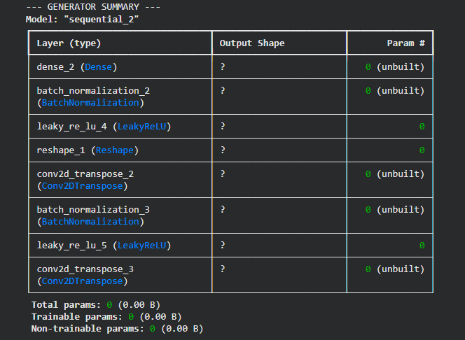

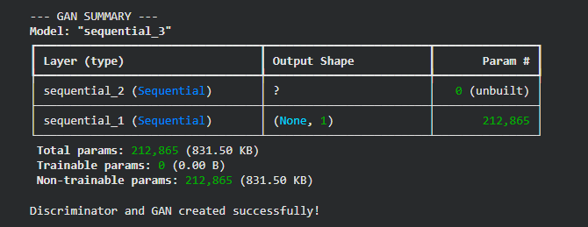
PART D: GAN TRAINING AND SYNTHETIC IMAGE GENERATION
Perform the following tasks:
- Initialize the Generator with random noise.
- Train the Discriminator using:
  - Real images from the dataset.
  - Synthetic images generated by the Generator.
- Train the Generator through the combined GAN model.
- Record:
  - Generator loss
  - Discriminator loss
- Repeat the training process for the specified number of epochs.
- Generate synthetic images at regular training intervals.
- Visualize generated images at different stages of training.
- Compare the generated images with real images.
- Analyze the quality and diversity of the generated images.
- Save the final generated images.
CODE:
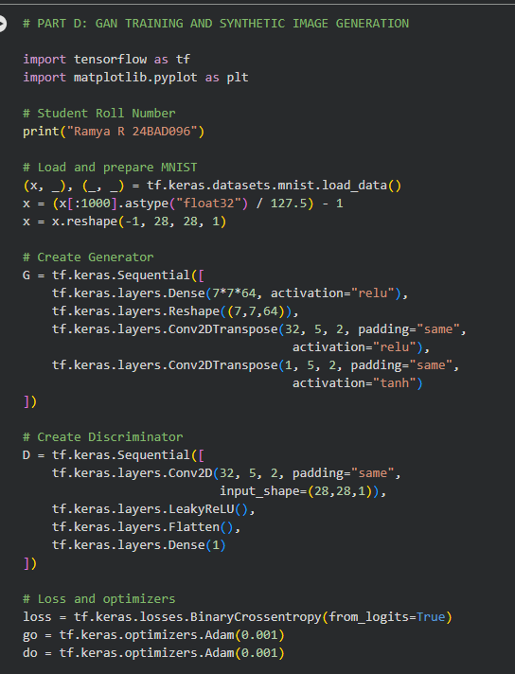

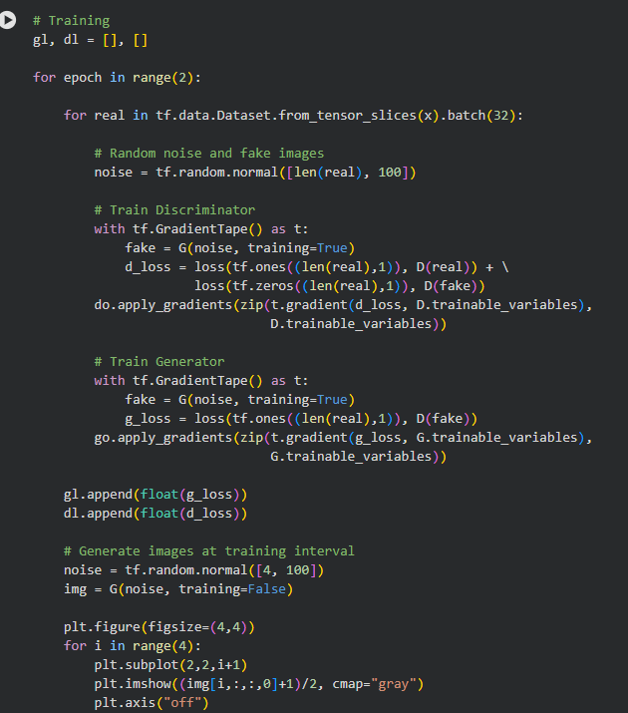

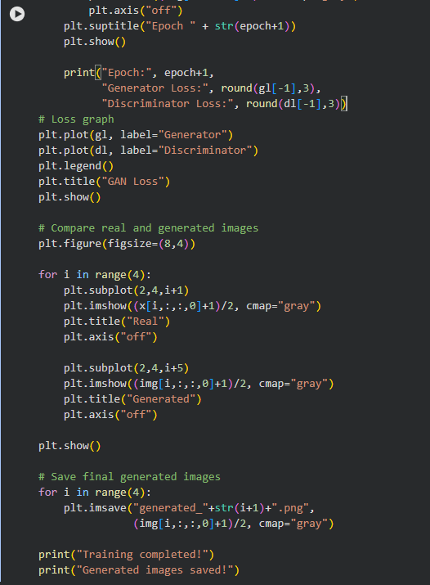
OUTPUT:
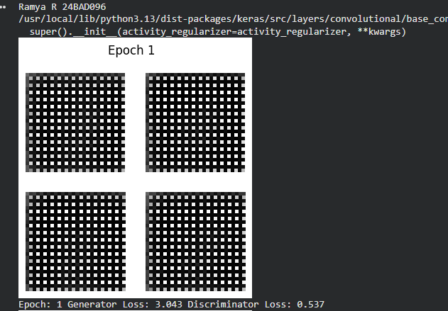
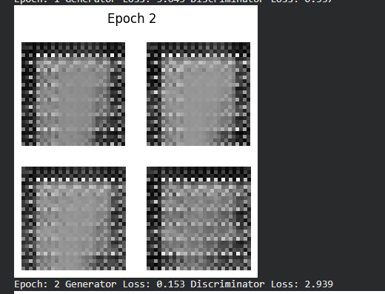
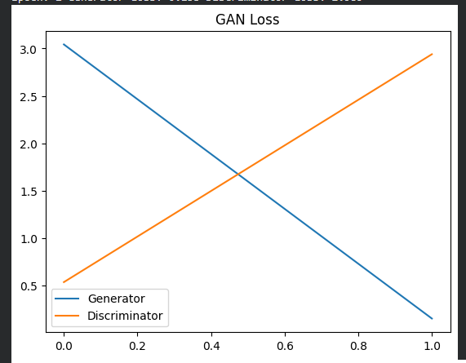

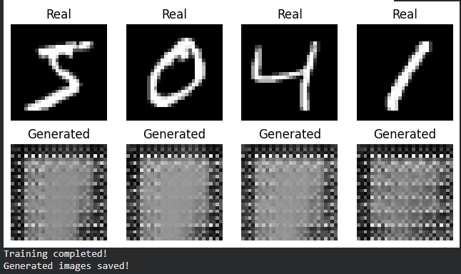

EXPECTED OUTCOME
Students will understand the architecture and working of Generative Adversarial Networks (GANs) and the interaction between the Generator and Discriminator during adversarial training. Students will learn to preprocess image data, build and train GAN models, and generate synthetic images. They will evaluate the generated images by visually comparing them with real images and analyzing the improvement in image quality during training.

POST-LAB QUESTIONS – EXPLAINABLE ANSWERS:
1. What is the role of the Generator in a GAN?
The Generator creates new synthetic data or images from random noise. It tries to make the generated images look similar to real images. During training, it learns from the feedback given by the Discriminator.
2. What is the role of the Discriminator in a GAN?
The Discriminator acts as a classifier. It receives both real images and generated images and tries to identify whether they are real or fake. Its feedback helps the Generator improve.
3. Why is random noise used as input to the Generator?
Random noise provides a starting point for the Generator to create images. Different noise values can produce different images, which helps the GAN generate new and diverse samples.
4. What happens when the Discriminator becomes too strong during GAN training?
If the Discriminator becomes too accurate, it can easily identify fake images. As a result, the Generator receives very little useful feedback and may find it difficult to improve its generated images.
5. What is meant by mode collapse in GANs?
Mode collapse is a problem where the Generator produces very similar or repeated images instead of different images. This means the Generator has learned only a small part of the data distribution.
6. How does the Generator improve the quality of generated images during training?
The Generator tries to fool the Discriminator. When the Discriminator identifies generated images as fake, the Generator uses this feedback to update its weights. Repeated training gradually helps it produce more realistic images.
7. Mention one real-world application of GANs.
One application of GANs is image generation. GANs can create realistic human faces, objects, or other images that do not exist in the real world.
8. What is the difference between GAN training and conventional neural network training?
In conventional neural network training, a model learns by comparing its prediction with the actual answer and minimizing the error. In GANs, two networks—the Generator and Discriminator—are trained against each other, where the Generator creates fake data and the Discriminator identifies it.

SUGGESTIONS FOR DATASETS
- MNIST Handwritten Digits – https://www.tensorflow.org/datasets/catalog/mnist
- Fashion-MNIST – https://www.tensorflow.org/datasets/catalog/fashion_mnist
- CIFAR-10 – https://www.tensorflow.org/datasets/catalog/cifar10
- CelebA – https://www.tensorflow.org/datasets/catalog/celeb_a
- Oxford-IIIT Pet Dataset – https://www.tensorflow.org/datasets/catalog/oxford_iiit_pet

ASSESSMENT
Description | Max Marks | Marks Awarded
Pre Lab Exercise | 5
In Lab Exercise | 10
Post Lab Exercise | 5
Viva | 10
Total | 30
Faculty Signature

